**ASSIGNMENT: DATA MIGRATION AND CSV IMPORTS**

1. **What is CSV Import? What is the navigation for CSV import? Which steps are involved in this process?**

* CSV is known as Comma Separated Values.
* It is a text file format that uses commas to separate values, and newlines to separate records.
* A CSV file stores tabular data in plain text, where each line of the file typically represents one data record.
* It reduced the data processing time and manual human errors.

Navigate to, Setup -> Import/Export -> Import CSV Records

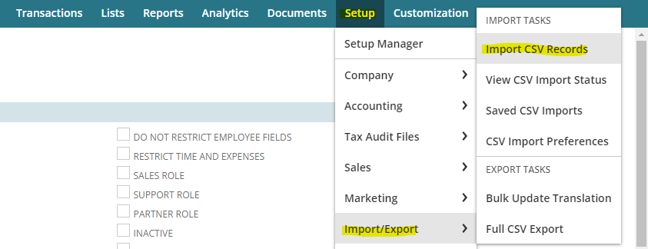

There are five steps involved in it.

1. ***Scan & Upload CSV File:***

* Choose the import type (e.g., item, relationship).
* Select the record type (e.g., groups, projects).
* Set the file encoding and column delimiter.
* Decide if you’re uploading a single or multiple files.

1. ***Import Options:***

* Choose how to handle data: Add (new records), Update (existing records), or Add or Update (both).
* Adjust advanced settings like custom forms and duplicate prevention.

1. ***File Mapping:***

* For multiple files, map them by selecting primary and key columns to link data between files.

1. ***Field Mapping:***

* Match CSV file fields to NetSuite fields by selecting them in the mapping interface.

1. ***Save Mapping & Start Import:***

* Name your import map and optionally describe it.
* Enter a unique Script ID for reference in SuiteScript.

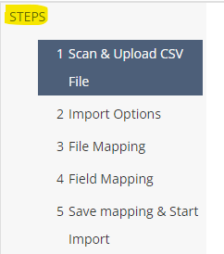

1. **What is ADD, UPDATE, ADD OR UPDATE? Explain.**
2. ***ADD***: We use it when we want to add an entirely new record. It won't update the existing record. If any record matches with it by its identifier, it will get skipped. It is useful when we import our data for the first time or add any new entries to the record.
3. ***UPDATE***: We choose this option when we have to update any existing record based on the matched identifiers. If a record is found with the same identifiers, the import will update the fields with the new data from the CSV. If in case, no matches are found then it adds as a new one.
4. ***ADD OR UPDATE***: This option combines both the “Add” and “Update” It will add new records and update existing ones based on matching identifiers. If a record exists, it will be updated; if not, a new record will be added.

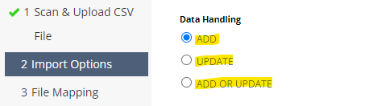

1. **If you want to create new records in NetSuite by csv import, which import option must you use?**

If we want to create a new record in NetSuite by CSV import, then we must use ADD import option. Because we use it when we want to add an entirely new record. It won't update the existing record. If any record matches with it by its identifier, it will get skipped. It is useful when we import our data for the first time or add any new entries to the record.

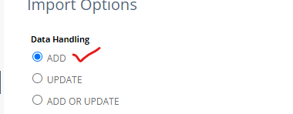

1. What is field mapping? How can we map CSV file fields with NetSuite fields?
2. How can we check our csv import job status? What is navigation?
3. How can we find our existing csv imports? What is navigation?
4. Find out the possible types of errors that occur while importing a CSV file in NetSuite? (User must implement and paste snippets in the assignment)
5. How can we block the import of records that appear to be duplicates?
6. What is the navigation for CSV templates?
7. Import the CSV file containing the following employee details?

* Name (First Name, Middle Name, Last Name)
* Email
* Phone
* Subsidiary
* Department
* Job Title